Useradd, Usergroup, Gpasswd, Gzip, wget

**Useradd** = if we want t create a useradd we use this command:-

* User have not a access to do anything compare to admin but admin have a access to do anything.

**ubuntu@ip-172-31-32-90:~$** sudo su

create a root user

**root@ip-172-31-32-90:/home/ubuntu#** useradd satyam

create a user and user name is satyam

**root@ip-172-31-32-90:/home/ubuntu#** cat /etc/passwd

we use this this command to check our **user.**

We use **passwd** to check our user

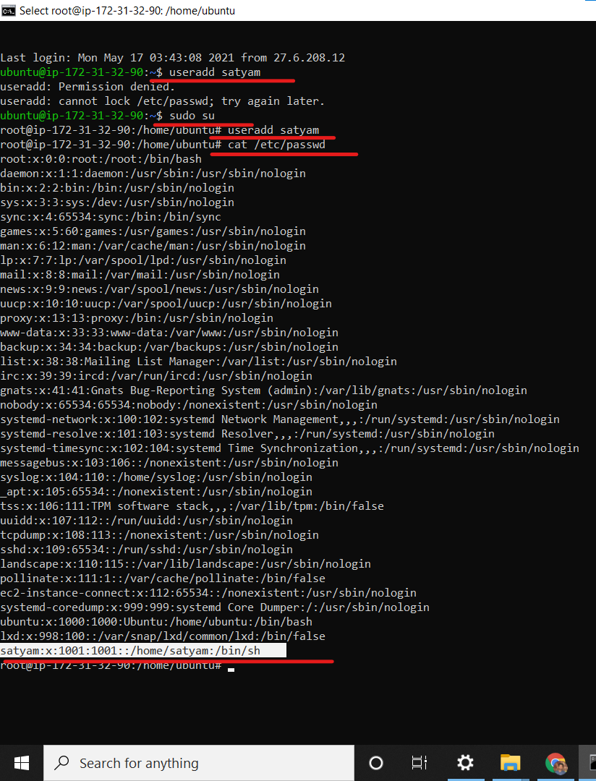

**Groupadd** = if we want to use groupadd we use this command:-

**ubuntu@ip-172-31-32-90:~$** sudo su

**root@ip-172-31-32-90:/home/ubuntu#** groupadd Tripathi

we use this command to create a group

**root@ip-172-31-32-90:/home/ubuntu#** cat /etc/group

we use this command to check our group

* If we create firstly user so automatically username group will create if previously no group will be available, but if previously group is available so automatically group will not create it.

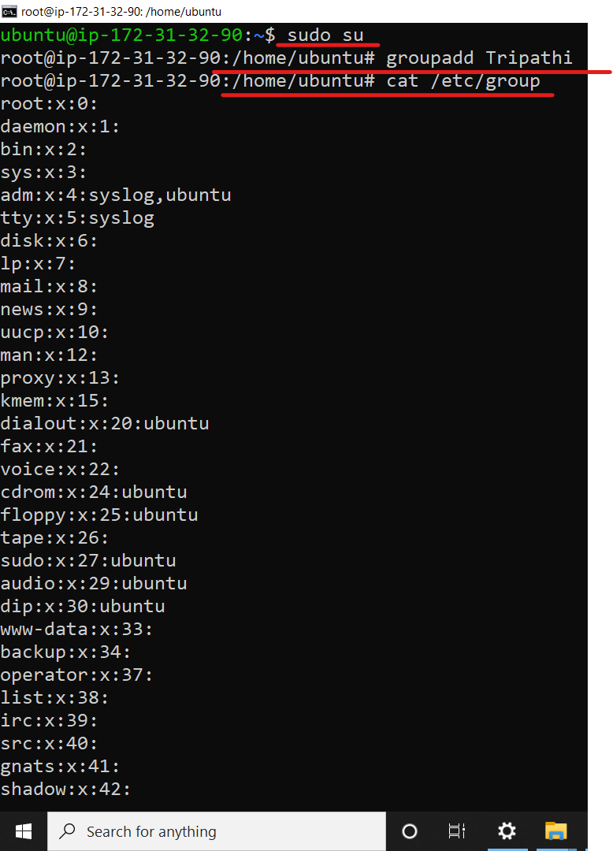

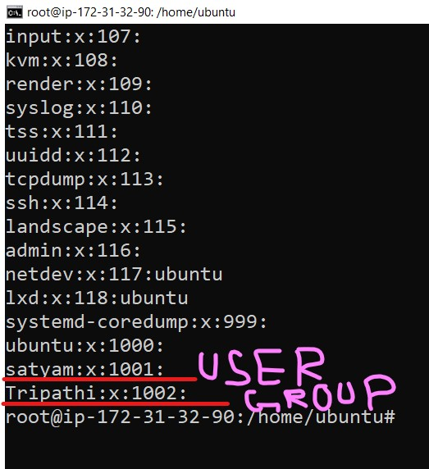

gpasswd =

* We use gpasswd to add a single user into group ,to add multiple user.
* if we want to add user in group means if I have already created previously group and I want to add user in the group, so we use this command .
* if we want to add a single user in a group we use this command

**gpasswd –a user1 newgrop1**

**->> -a** command will use to add a single user in a group.

**->>** Here **user1** is a username & **newgroup1** is group name

and here previously we created a userame afterthat we add a user in a group

->> Now you see user1 is a member of a newgroup1.

* if we want to add a multiple user in the group we use this command:-

**gpasswd –M user1,user2,user3,user4 newgroup1**

**->> -M** command use to add multiple user in a group

->> Here user1 user2 user3 user4 they all are user and we want to add all user in the newgroup1 so we use this command.

ln -s -> we use this command to create a shortcut of any file or any path

ln –s file1 softfile1

For e.x., if we download any software like google chrome in our system we see in our desktop one shortcut file will be created in or desktop , it means if we delete shortcut file there are no problem come because we not delete our permanent file we delete our temporary file .